

NATIONAL INSTITUTE OF INFORMATION TECHNOLOGY(NIIT),

PORT HARCOURT

CYBERSECURITY PROJECT ON DIGITAL FORENSICS

PROJECT TITLE: A DIGITAL FORENSICS PROJECT TO EXAMINE A GIVEN FORENSIC IMAGE OBTAINED FROM THE WORKSTATION OF APEX INTEGRATED TECHNOLOGIES LTD INVOLVED IN A SUSPECTED DATA
DELETION INCIDENT.

CASE ID: AIT-DF-2026-009

INVESTIGATOR: EKWEBELEM SONIA
DATE: 27TH SEPTEMBER, 2026

;.

INTRODUCTION
Executive Summary
This report presents the digital forensic examination of a forensic disk image provided in relation to a suspected data deletion incident involving a workstation belonging to Apex Integrated Technologies Ltd. The investigation focuses on determining the status and recoverability of six identified folders: SSH, My pic, Our pic, ADDS Project, Corel, and Corel Draw Work.
The supplied evidence, Evidence.E01, was preserved and its integrity verified using SHA-256 hashing before forensic examination. A working copy was created using DD and produced the same SHA-256 hash as the supplied evidence. The investigation uses DD, R-Drive Image, FTK Imager and Autopsy to examine the filesystem, identify deleted data, recover relevant files where possible, analyse metadata and timestamps, and correlate findings across the forensic tools.
At the current stage of examination, Autopsy has identified filesystem and deleted-file artifacts relevant to the investigation. Detailed examination of the target folders, recovery results and timeline evidence is documented in the subsequent sections of this report. Final conclusions concerning the deletion timeframe, recoverability of evidence and limitations are based only on artifacts supported by the forensic evidence.
This covers what the assignment expects from the executive summary why, what was examined, major findings/recovery, timeline and limitations without prematurely inventing our final findings.

CASE BACKGROUND
Apex Integrated Technologies Ltd. initiated a digital forensic investigation following the suspected disappearance of folders and files from one of its workstations. A forensic image of the relevant storage device was provided for examination under Case ID AIT-DF-2026-009.
The investigation was commissioned to determine whether the identified folders and their contents were present or had been deleted, establish what data could be recovered, examine relevant filesystem artifacts and metadata, and determine the most defensible timeframe for the deletion-related activity.
The folders identified for investigation are SSH, My pic, Our pic, ADDS Project, Corel, and Corel Draw Work. The investigation also seeks to determine what conclusions can reasonably be supported regarding the circumstances surrounding the deletion while avoiding unsupported assumptions concerning user identity or intent.
That last sentence is important because the project specifically requires forensic reasoning about whether we can establish who deleted the files and whether deletion was intentional.

OBJECTIVES OF THE INVESTIGATION:
- To examine the given forensic image and investigate the disappearance of the following folders(SSH, My pic, Our pic, ADDS project, Corel, Corel Draw work)
- To determine if the content of these folders are (present, deleted, partially deleted, recoverable, partially recoverable, unrecoverable).
- To investigate the available evidence to determine the most defensible time frame in which the deletion activity occurred.

SCOPE
The scope of this investigation is limited to the forensic examination of the supplied Evidence.E01 disk image and verified forensic working copies derived from it. The examination covers evidence integrity verification, filesystem and directory analysis, deleted-file identification and recovery, file and folder metadata, relevant timestamps, user and system artifacts, and timeline reconstruction.
Particular attention is given to the six target folders: SSH, My pic, Our pic, ADDS Project, Corel, and Corel Draw Work. Relevant artifacts found elsewhere within the forensic image may also be examined where they assist in establishing the existence, deletion, recovery or timeline of the target data.
The investigation does not extend beyond the supplied forensic evidence and associated working copies. Conclusions regarding the identity of the individual responsible for deletion, the intention behind any deletion activity, or actions not supported by available forensic artifacts will not be made without sufficient evidence.

EVIDENCE DESCRIPTION AND IDENTIFICATION
The evidence given for this analysis was a forensic disk image file; with the following specifications
- EVIDENCE FILE NAME: EVIDENCE.E01
- FILE EXTENSION: .EO1
- EVIDENCE FILESIZE: 10MB
- IMAGE FORMAT: EWF/Expert Witness/Encase Image File format
- AVAILABLE PARTITIONS:
- FILE SYSTEMS:
- OPERATING SYSTEM: Kali Linux and windows 10
- USER ACCOUNT: Ifeoma
- ACQUISITION DATE/TIME: 2026-09-24T15:24:00-01:00
- SHA-256 HASH: 6216149fddf6eb7074349afaef226f02c3b246ee6c3c3ae91c5ab7adeb8c29e0

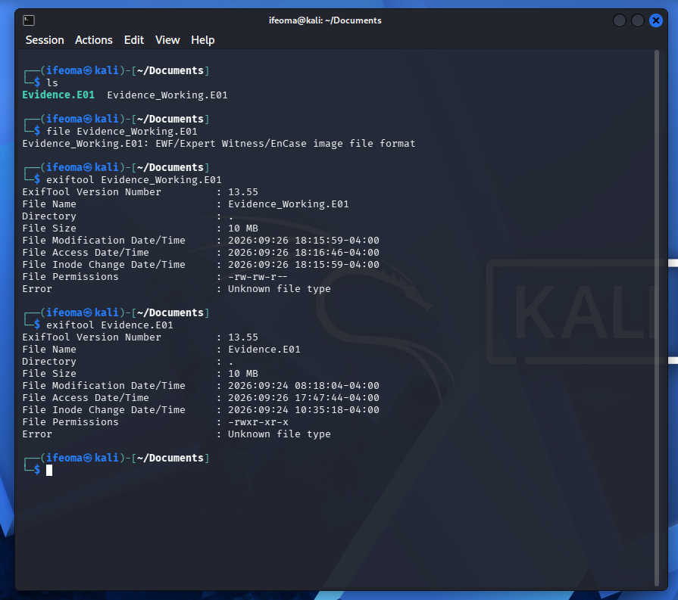

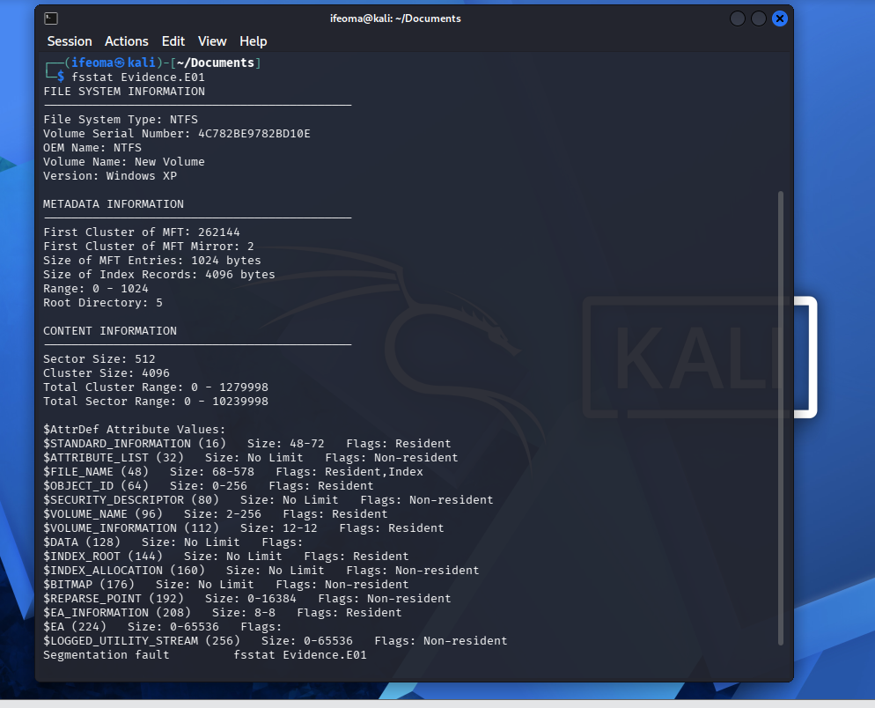

EVIDENCE INTEGRITY
- CRYPTOGRAOHIC ALGORITHM USED: SHA-256
- ORIGINAL HASH VALUE: 6216149fddf6eb7074349afaef226f02c3b246ee6c3c3ae91c5ab7adeb8c29e0
- HASH VALUE OF WORKING COPY: 6216149fddf6eb7074349afaef226f02c3b246ee6c3c3ae91c5ab7adeb8c29e0

A forensic image of the given evidence was first created using the dd tool and corresponding hash value created and compared with the original hash value of the original evidence given. This was done on both Kali Linux and windows 10 as shown below.

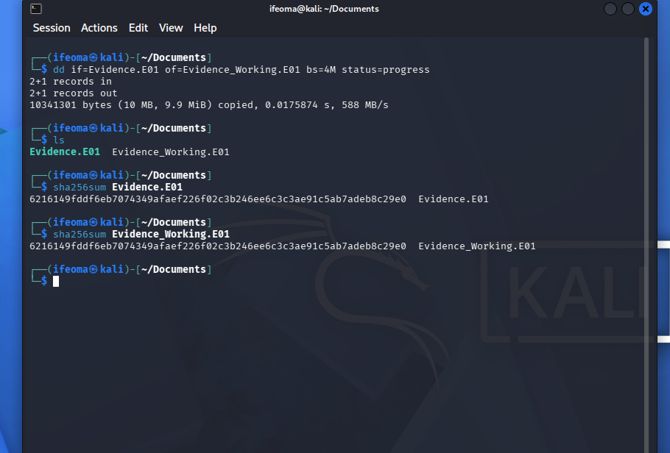

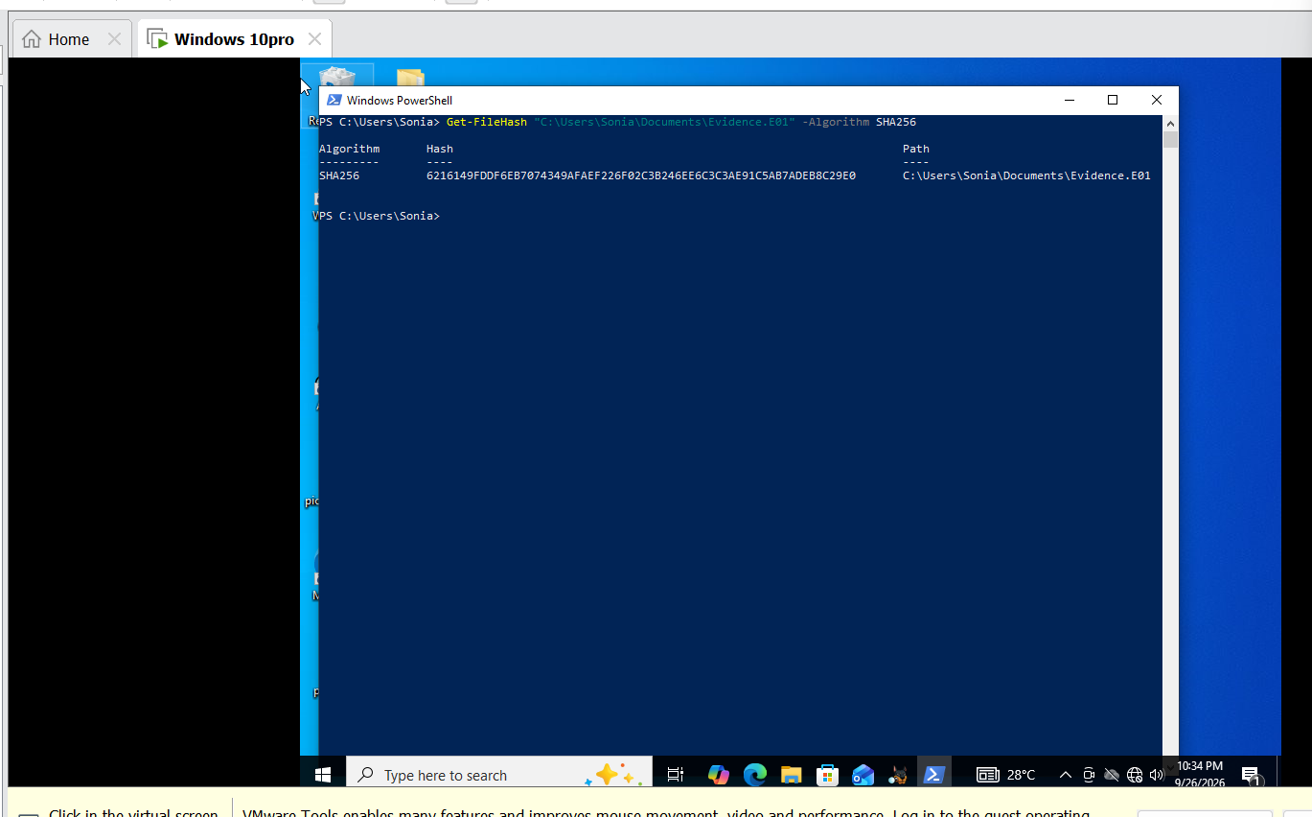

Yes, the working copy(Evidence_Working.E01) produced the same hash value as seen in our screenshot.
Hashing is important in digital forensics because it verifies that the forensic image has not been altered.
If the hash value changed unexpectedly, it simply indicates that the evidence may have been modified or corrupted. Here, the hash values are the same, indicating authenticity of our working copy.

TOOLS USED
- Autopsy
- R-Drive Imager
- FTK Imager
- DD
- Windows Power shell

METHODOLOGY
The forensic investigation was conducted using a structured process to preserve evidence integrity and systematically examine the supplied digital evidence. The investigation involved the following stages:
- Evidence Acquisition: Forensic images/copies of the provided evidence were acquired using FTK Imager and the dd utility. The original evidence was not used for routine analysis after acquisition.
- Evidence Verification: Cryptographic hash values were used where available to verify the integrity of the acquired evidence and ensure that the forensic copies remained unchanged during examination.
- Evidence Examination: The acquired evidence was examined using FTK Imager, R-Drive Image and Autopsy. The file system, allocated and unallocated space, deleted files, metadata and other relevant artifacts were inspected.
- Target Folder Investigation: Particular attention was given to the specified target folders: SSH, My pic, Our pic, ADDS Project, Corel and Corel Draw Work. Their contents, file types, metadata, timestamps and deletion/recovery status were examined.
- Deleted File Analysis: Deleted-file records and unallocated data were examined to identify significant deleted items associated with the target folders. Keyword searches were also performed for relevant folder and file names to locate references in filesystem artifacts.
- Metadata and Timeline Analysis: Available created, modified, accessed and changed timestamps were examined to establish the sequence of relevant file activities.
- Recovery and Validation: Recoverable deleted files and relevant artifacts were identified, and findings from the forensic tools were compared where possible to validate the results.
- Documentation: Relevant findings, file information, hashes, timestamps and screenshots were recorded to provide supporting evidence for the investigation.

FTK IMAGER FINDINGS:

DD FINDINGS: The dd utility was used during the evidence acquisition process to create a forensic copy of the target data. The source evidence was copied into a disk image to allow forensic examination to be performed on the copy rather than directly on the original evidence.
The acquisition process successfully produced a .dd forensic image, which was subsequently verified by accessing/mounting the image and confirming that the expected contents were present.
The use of dd provided a sector-level copy of the selected evidence, allowing the acquired image to be preserved for subsequent forensic examination.
Activities performed:
- Identified the source evidence.
- Created a forensic image using dd.
- Confirmed successful completion of the imaging process.
- Verified that the resulting .dd image was accessible.
- Confirmed that the expected evidence was present within the forensic copy.
- Finding: The acquisition was completed successfully, and the resulting forensic image was suitable for subsequent examination.

- DRIVE FINDINGS:

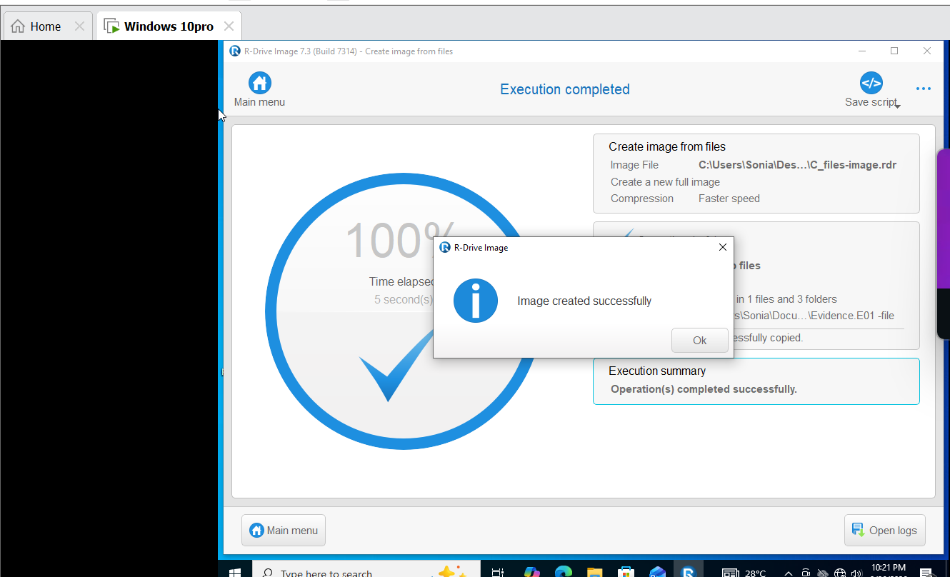

AUTOPSY FINDINGS:
The forensic image Evidence.E01 was loaded and analysed using Autopsy 4.23.1. Autopsy successfully processed the image and provided access to the file system, deleted-file records, metadata, timestamps, keyword-search results and allocated/unallocated data.
File-System Analysis
Examination of the file system revealed several directories and artifacts relevant to the investigation. The specified target folders, including SSH, Corel and Corel Draw Work, were identified within the evidence. References associated with My pic, Our pic and ADDS Project were also identified through keyword searches and filesystem artifacts.
Autopsy displayed file information including file names, paths, sizes, allocation status, MIME types, hash values and available timestamps.

